[Test Plan] Belajar Bareng version 1.0

Document Status | DRAFT
Test Plan Creator | Suwandy
Test Plan Reviewer | - Janitra  - Wandi

Introduction

Overview Features to be tested

This Test Plan is made to ensure that Login and Add User on belajar-bareng.onrender.com website function properly and meet the criteria according to user needs. The rest of the features are deemed out of scope.

Goals and Objective

Phase 1 of the project will deliver TCT (Test Case Tamer) with functionality to login and add user tests. This will allow the test team to start adding new user to the new system.

The belajar-bareng.onrender.com website is a website that simulates a simple user management that has features such as a login page, and adding, removing, displaying list of users. The stages of testing the features carried out by manual testing (Manual Test) are as follows:

- Testing the Login page features aims to ensure users do not experience problems when performing the login and logout process. The test scenario is to use a valid username, invalid.
- Adding User page aims to add new users with proper rules such as only can add new unique username, and valid age.

Test Item
List of test items (feature / product)

No | Feature | Test Item
#1 | Login | - Login with valid credentials  - Login with invalid credentials  - Login with user doesn’t exist
#2 | Add User | - Adding with username longer than limit  - Adding with age longer than limit  - Adding with existing username  - Adding with valid username and age

In Scope Testing
List of in feature to be tested

No | Feature | Requirement / Design specifications
#1 | Login | 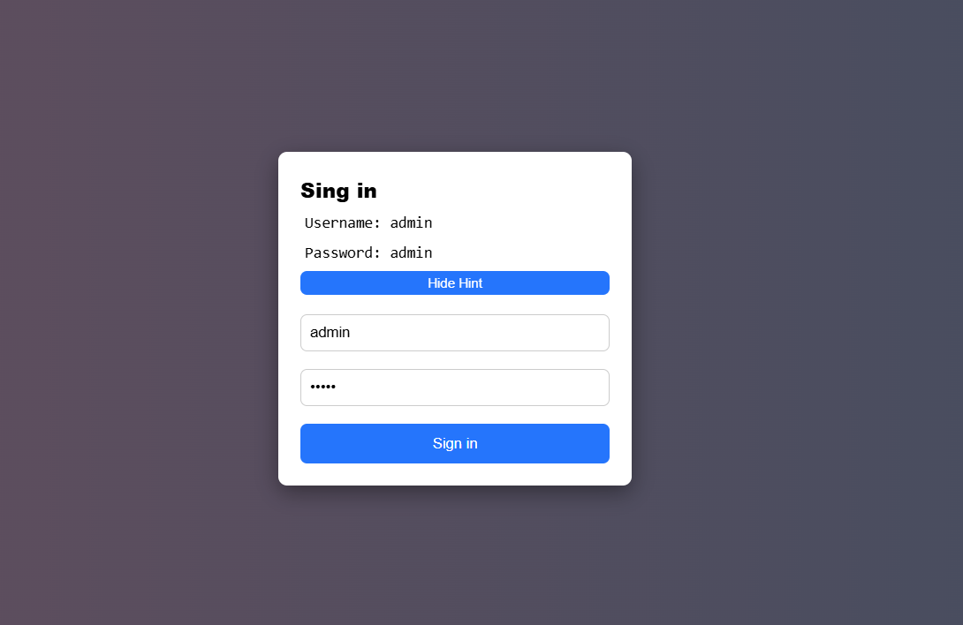
#2 | Add User | 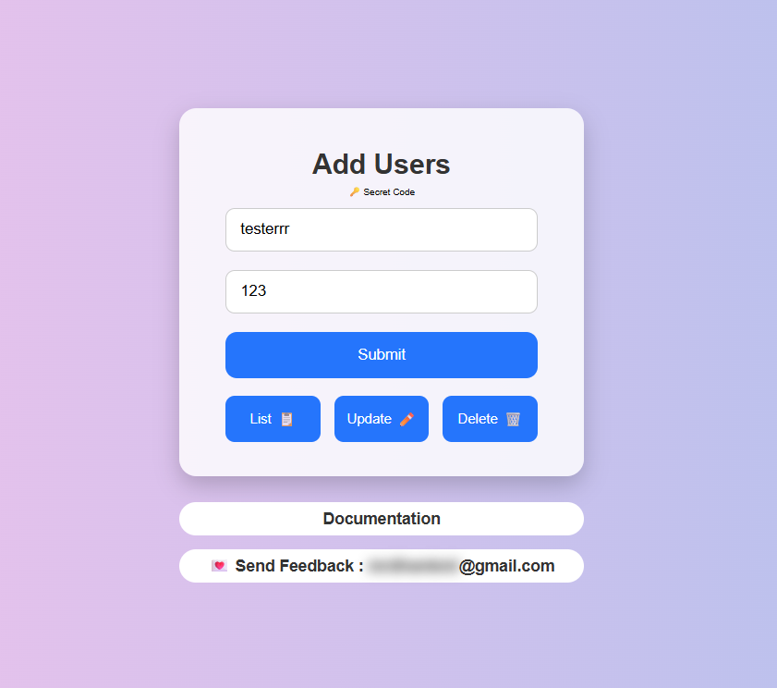

Out of Scope Testing
List the features of the software / product which will not be tested.

No | Feature | Reasons
#1 | Update User | This testing phase will be focus to test login and Adding User
#2 | Delete User | This testing phase will be focus to test login and Adding User
#3 | Checkout | This testing phase will be focus to test login and Adding User

Testing Approach
Summary of testing approach that will be implemented during testing phase

The project is using an agile approach, with weekly iterations. At the end of each week the requirements identified for that iteration will be delivered to the team and will be tested.

Exploratory testing will play a large part of the testing as the team has never used this type of tool and will be learning as they go. Tests for planned functionality will be created and added to TCT as we get iterations of the product.

Test Environment
Information about testing environment that will be used during testing phase e.g URL, and version of App
- Website: https://www.belajar-bareng.onrender.com/
- Env: Production
- Browser: Chrome v144.0.7559.110

Test Deliverables
- Test Plan (this document itself)
- Test Case
- Bug Report

Testing Timeline

No | Task | Estimation Time |  | Actual Time
No | Task | Start Date | Finish Date | Start Date | Finish Date
#1 | Develop Test Planning | 30 Jan 2026 | 30 Jan 2026 | 30 Jan 2026 | 30 Jan 2026
#2 | Develop Test Case | 30 Jan 2026 | 30 Jan 2026 | 30 Jan 2026 | 30 Jan 2026
#3 | Test Case Review | 30 Jan 2026 | 30 Jan 2026 | 30 Jan 2026 | 30 Jan 2026
#4 | Execute Test | 30 Jan 2026 | 30 Jan 2026 | 30 Jan 2026 | 30 Jan 2026

